1. **Agenda**:
   1. We will create a subscriber(Consumer) to a Topic.
   2. Then we will run the consumer once so that it could subscribe to the topic.
2. 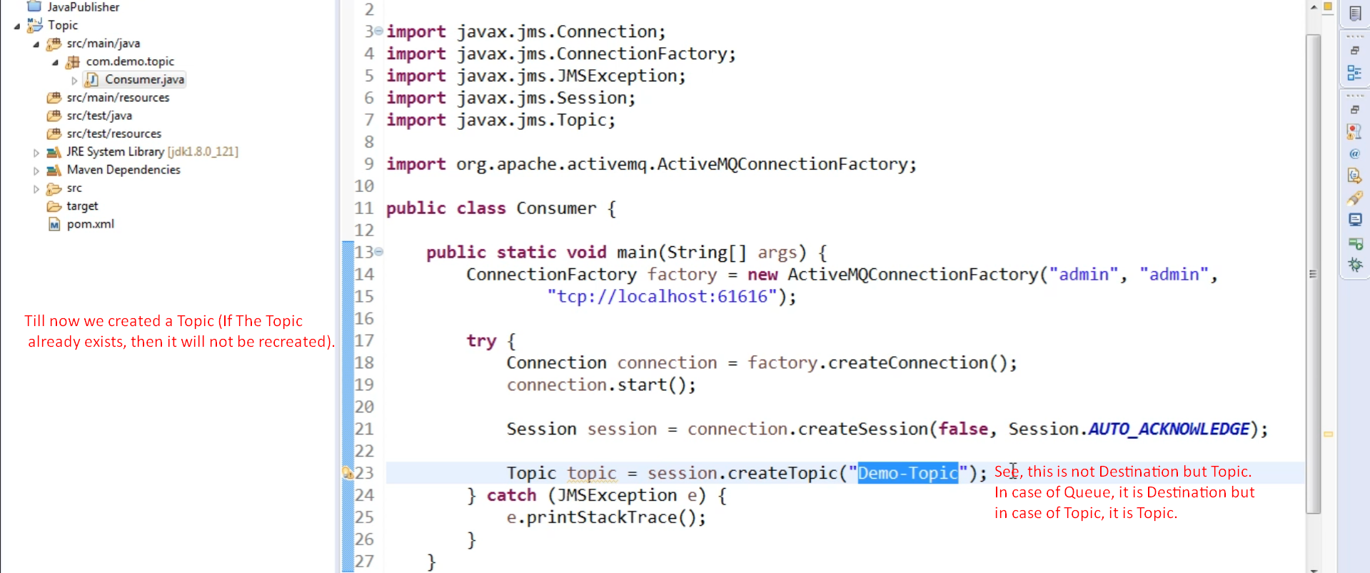
3. Now to proceed further, we need to know about the **Durable Subscriber**.
   1. Suppose, you have a subscriber which has subscribed to Topic Demo-Topic.
   2. But due to some reason, say some error or some maintenance, your subscriber goes off.
   3. Meanwhile, your Topic Demo-Topic gets three messages.
   4. All the active subscribers will get those three messages.
   5. But what about the offline subscriber which is now offline but already subscribed?
   6. When that offline subscriber comes online, it will get the three messages.  
      That is the application of **Durable Subscriber**.  
      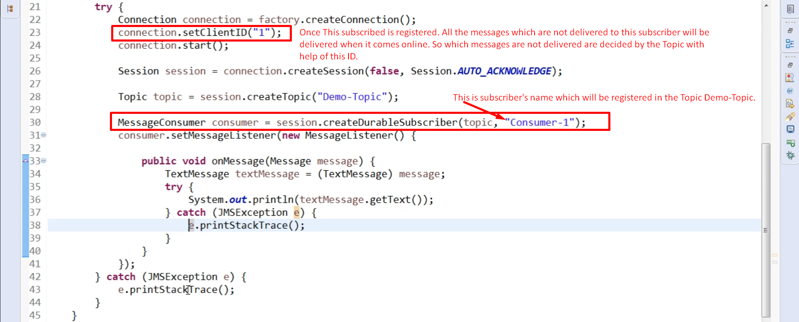
4. Let’s run the above Subscriber.  
   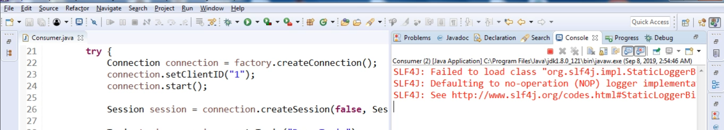
5. Let’s see the Subscribers of the Topic Demo-Topic  
   A picture containing table

   Description automatically generated
6. 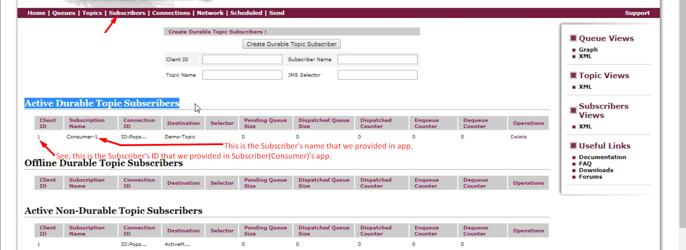
7. Graphical user interface, text, application

   Description automatically generated
8. Graphical user interface

   Description automatically generated